Development of a Radiation Simulation Tool for Conceptual Design of Lunar Habitats

Nomenclature
GCR – Galactic Cosmic Rays
SPE – Solar Particle Events
D – absorbed dose (Gy)
H – dose equivalent (Sv)
Q – radiation quality factor
L – unrestricted linear energy transfer (LET) in water (keV/µm)
T – kinetic energy per nucleon
R – dose response (organ dose per unit free-field fluence)
E₀ – proton rest energy (938.272 MeV)
Φ / ϕ – solar modulation potential (MV)
LIS – Local Interstellar Spectrum

1. Introduction
The return of humanity to the Moon has recently become a highly sought out endeavour. To establish occupation on the Moon, however, its harsh radiation environment must be understood and protected against. Unlike the Earth, the Moon has no significant atmosphere or magnetic field surrounding it. Its surface is exposed to galactic cosmic rays (GCR) and solar particle events (SPEs) as well as secondary radiation generated when primary particles interact with the lunar soil [1,2]. Radiation particles are a threat to astronauts’ health and the functionality of technological equipment.
The level of radiation experienced also varies depending on the solar cycle as a higher GCR flux is seen during solar minimum than during solar maximum [3]. For evaluating SPE protection, the selected event of model is also consequential because different methods applied to the same data set can produce significantly different results, leading estimates to differ by a factor of two or more [4].
NASA standards currently in place suggest minimising crew exposure to as low as reasonably achievable (ALARA) [5] and set a career effective-dose limit at 600 mSv [6]. ESA has its own set of limits, defining the maximum career effective-dose limit at 1000 mSv [7]. These values serve as benchmark career limits; however, because the numerical limits follow different conventions, the tool treats them as comparison benchmarks rather than as model inputs, with the exact definition of the evaluated dose quantity stated in the methods. Comparable in-flight benchmarks exist from phantom measurements outside the ISS [8].
Lunar regolith is a promising potential shielding material because it is available in-situ, with well-characterised geotechnical properties relevant to construction [9]. Its shielding performance is not a simple function of thickness, however, as primary particles interacting with the soil produce secondary particles and modelled fluxes can peak at various distances below the surface, depending on the particle type and the energy [1]. Studies have investigated regolith combined with aluminium and polyethylene [10] and various types of hydrogen-rich materials for GCR and SPE shielding [11,12], although risk-based assessments show shielding materials to be only marginally effective against the penetrating GCR field. Local terrain could also affect the level of incident radiation exposure based on a (PHITS) study that found reduced effective-dose equivalent estimates for habitats positioned next to crater walls compared with a full-exposure case, with the reduction depending on the crater depth and location [13].
Simulating radiation particle propagation provides a means to examine and model the interactions across particle types, energies, materials, and geometries. Geant4 is a Monte Carlo toolkit that supports particle transport through matter with user-defined geometries, materials, and physics processes [14-16]. TOPAS builds on this general-purpose Monte Carlo code to provide a more accessible and user-friendly simulation platform [16]. Some tools exist already for evaluating radiation effects in space. One such tool is OLTARIS, which supports the assessment of complex geometries [17], but its lunar-surface implementation is simplified, with the neutron-albedo contribution not yet fully incorporated, which limits its use as a benchmark for the secondary environment; it in turn builds on the deterministic HZETRN transport code [18], whose physical foundations are reviewed by Durante and Cucinotta [7]. REDMoon is another tool which provides detailed, direction- and depth-dependent lunar radiation spectra [1].
This work presents the development of a radiation simulation tool for conceptual design studies of space stations and lunar surface habitats. Using TOPAS, the tool is intended to characterise the lunar radiation environment and support simulations of user-defined habitat shapes and wall configurations, including multiple materials and layers of specified thicknesses. Its graphical user interface (GUI) is designed to let users define and compare candidate configurations. The aim is to support early-stage trade studies of how habitat geometry and layered shielding affect predicted radiation exposure, while making the assumptions and limits of each simulation explicit.
The environmental models implemented are based on a local interstellar spectrum modulated to a chosen solar epoch by the force-field approximation [19], with abundances of transported ion groups near solar minimum [20,21,22], and historical solar-particle-event spectra [23]. The reported dose quantities are evaluated by scoring absorbed dose and dose-equivalent with ICRP-60 and NASA quality-factor models [20,24], reported separately for the GCR and SPE contributions in line with their distinct dosimetric limits [5,6]. Validation of the results is done by comparing the absorbed surface dose with the Chang’E-4 Lunar Lander Neutron and Dosimetry measurement [25], and the absorbed and skin doses behind aluminium shielding against the OLTARIS deterministic tool [17], with the whole-body effective dose reported as an independent estimate.

2. Simulation Methodology

2.1 Transport code and physics
Particle transport was performed with TOPAS (v3.8) [16], a layered interface to the Geant4 toolkit [14,15]. The reference physics list is FTFP_BERT_HP whereby hadronic interactions are handled by the Bertini intranuclear cascade below 10 GeV and the Fritiof string model above 10 GeV, and the high precision neutron package included tracks neutrons down to thermal energies using the evaluated G4DL 4.6 neutron data library [26]. Electromagnetic interactions are handled by the standard G4EmStandardPhysics constructor and particle production thresholds were left at the TOPAS default range cut (0.05 mm for all particles). High-precision neutron transport is essential because a substantial fraction of the crew dose behind thick shielding structures is carried by low-energy secondary (albedo) neutrons bred in the regolith and/or habitat walls. Thus, a standard-precision list would misinterpret that component.
Simulations are run multithreaded. The results reported below combine independent random-seed replicas and statistical uncertainties are quoted as the standard error across replicas.

2.2 Lunar surface environment and habitat geometry
The lunar surface was modelled as a semi-infinite regolith half-space beneath a vacuum world. The regolith composition is based on an Apollo-17 high-titanium mare soil, reduced to its eight dominant elements and renormalised to unit mass fraction [27]. The lunar regolith is represented as three stacked layers of differing bulk density, following the Apollo-17 profile with the uppermost (lowest-density) layer at the surface and the top face also defining the habitat floor plane.
Pressurised habitats are built parametrically as one of four archetypes: hemispherical dome, vertical cylinder, lying half-cylinder, and a regolith-buried cylinder. Each habitat shape is defined by an internal free radius, a layered wall stack (engineered material plus, for the buried case, a variable regolith overburden), and a fixed-height crew phantom. All habitats stand on the regolith surface plane, so the geometry essentially reproduces the $2π$ surface illumination geometry, whereby the upper hemisphere is open and the half-space below is shielded.

2.3 Galactic cosmic-ray source model
The GCR primary spectrum is constructed from a local interstellar spectrum (LIS) modulated to a chosen solar epoch by the force-field approximation [19]. For protons the LIS of Usoskin [3] was used,
$$J_{LIS}(T)=\frac{1.9×{10}^{4} P^{-2.78}}{1+0.4866 P^{-2.51}} \left[m^{-2} s^{-1} sr^{-1} GeV^{-1}\right],$$
where $T$ is the kinetic energy per nucleon and P = √(T(T + 2E₀)) is the corresponding particle rigidity, in which the LIS spectral shape is evaluated (E₀ is the proton rest energy, defined below). The shape is parameterised in rigidity rather than in kinetic energy. Heliospheric modulation at force-field potential $ϕ$ (in MV) maps the LIS to the near-lunar differential intensity,
$$J(T)=J_{LIS}(T+Φ) \frac{T (T+2E_{0})}{(T+Φ) (T+Φ+2E_{0})}, Φ=\frac{Z}{A} ϕ,$$
where $E_{0}=938.272$ MeV is the proton rest energy [28] and $Z,A$ the charge and mass number. A worst-case deep solar minimum was adopted, $ϕ=400$ MV, representative of the 2019–2020 minimum.
The heavy-ion field is represented by five transported species in place of the full charge range, with number abundances relative to hydrogen taken near solar minimum [20,21], as shown in Table 1 below.
Table 1. Heavy-ion field representation.
Group | Transported ion | $$Z$$ | $$A$$ | Abundance (rel. H) | Charges represented
Z=1 | proton | 1 | 1 | 1.0 | H
Z=2 | $$α$$ | 2 | 4 | 0.105 | He
CNO | $​^{12}$C | 6 | 12 | 0.033 | Z = 3–9
Ne–Ca | $​^{28}$Si | 14 | 28 | 0.012 | Z = 10–20
Fe | $​^{56}$Fe | 26 | 56 | 0.0020 | Z = 21–28
This lumping trades per-element fidelity for tractability. Because dose-equivalent from HZE ions scales steeply with charge, the Fe group in particular is a representative of the high-LET Z = 21-28 peak rather than iron alone. The abundances are order-of-magnitude group values and are a stated source of systematic uncertainty.
Each species is sampled up to a per-nucleon ceiling of $T_{max}=20$ GeV/nucleon. This ceiling is a compute compromise, not a physical cutoff, because Geant4 particle shower cost scales with total energy while dose scales per nucleon, the heaviest ion (Fe, A = 56) already reaches 1.1 TeV at this ceiling, and higher-energy Fe showers become intractable. The truncation is dose-conservative and quantified. For the proton component it under-reports the skin dose by ≈5.6% relative to a 100 GeV/nucleon ceiling, because the dose is tail-dominated. The deep-shield response kernel folds the free-field spectrum to this same ceiling: an earlier build integrated only to the kernel’s highest transport node (5–6 GeV/nucleon), dropping the 5–20 GeV/nucleon band the source already supplies. Restoring that band raises the kernel effective dose by 4–6% at the in-regime thin-wall anchors (0–10 g/cm²) and by up to 19% at the 50 g/cm² anchor beyond the crossover, where the penetrating tail increasingly dominates the residual field; the fold-ceiling truncation is thus measured rather than assumed.
The incident field is isotropic over the unobstructed upper hemisphere. It was discretised into a set of parallel disc beams arranged in zenith rings $×$ azimuthal sectors, each firing inward. Because the flux crossing a flat surface from an isotropic field follows the Lambert cosine law, the flux from a zenith band $[θ_{1},θ_{2}]$ is proportional to $\sin^{2}θ_{2}-\sin^{2}θ_{1}$. Ring boundaries were therefore spaced equally in $\sin^{2}θ$ so that every ring carries equal flux and receives an equal number of histories, giving a directionally exact and statistically uniform illumination [1]. This construction makes the effective slant-path shielding, the flux-weighted $⟨1/cosθ⟩$ of the full hemisphere, emerge from the geometry rather than being imposed. Figure 1 below illustrates the particle visualisation feature of the GUI for a given habitat evaluation scenario.
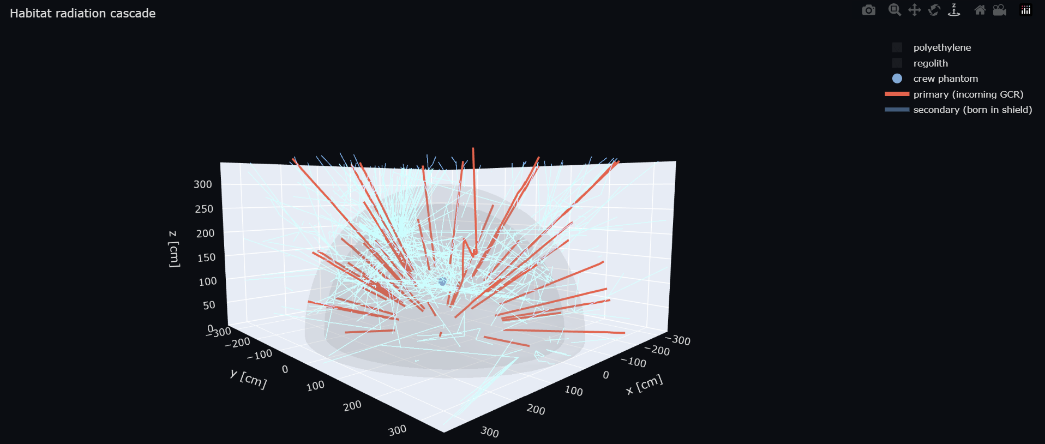
Figure 1. Particle transport visualisation.
TOPAS provides a native isotropic-field source that emits particles inward from an enclosing sphere under a built-in cosine angular distribution. However, that source was not used here as it illuminates the enclosed geometry over the full 4π angle, whereas a habitat resting on the regolith is exposed only over the upper hemisphere. The lower half is obstructed by the surface and the absolute normalisation relies on a fixed-radius outer-fluence gauge that requires the explicit, controlled source tilting described above. The constructed sky-dome thus reproduces from first principles the same cosine law that the environment source applies internally, so the directional weighting is transparent and independently verifiable. Each disc beam is monodirectional and draws its energy through TOPAS’s piecewise-linear continuous energy-spectrum sampling, whereby the spectrum is being supplied as relative differential intensities dN/dE at a set of energy nodes.

2.4 Solar particle event source
Solar particle events (SPEs) are modelled as a directional proton field. They follow a single look direction (the Sun) with a finite angular cone, in contrast to the omnidirectional GCR field. Event-integrated proton fluence spectra for historical reference events [23] (e.g. the August 1972 event) drive an acute, event-total assessment. GCR and SPE contributions are assessed and reported separately and are never summed into a single number, reflecting their distinct character (chronic background vs. acute event) and dosimetric limits [6,24].

2.5 Dose quantities and quality factors
Three dose quantities are scored. Absorbed dose $D$ (Gy) is accumulated with the standard TOPAS energy-deposition scorer. Dose-equivalent $H$ (Sv) is computed per step from the radiation quality factor, evaluated in two independent models implemented as custom Geant4 scorers so that transport and LET evaluation are identical and only the quality-factor mapping differs.
The first uses the ICRP Publication 60 quality factor as a function of unrestricted LET $L$ in water (keV µm$​^{-1}$) [24]:
$$Q(L)=\left\{\begin{matrix}1 & L<10 \\ 0.32 L-2.2 & 10≤L≤100 \\ 300/\sqrt{L} & L>100.\end{matrix}\right.$$
At each step the scorer computes the unrestricted electronic LET of the stepping particle from its stopping power, maps it to $Q(L)$, and accumulates $edep⋅Q(L)/m$. Neutral primaries deposit through charged secondaries that step separately, so a step with no defined charged LET is assigned $Q=1$.
The second uses the NASA/Cucinotta space-radiation quality factor for solid-cancer risk [20], which depends on track structure ($Z^{*2}/β^{2}$) and energy, not on LET alone:
$$Q=(1-P)+\frac{X}{L} P, P=[1-e^{-(Z^{*2}/β^{2})/κ}]^{m}\left[1-e^{-E/0.2}\right],$$
with $X=7000$ keV µm$​^{-1}$ (solid-cancer peak-height constant), $E$ the kinetic energy per nucleon (MeV/u), $L$ the LET, and $Z^{*}=Z\left[1-e^{-125βZ^{-2/3}}\right]$ the Barkas effective charge. Reporting the same field under both the ICRP-60 and NASA-2013 quality factors, whose dose-equivalent formalism descends from the NASA transport framework [29] lets the design comparison expose the model dependence of the dose-equivalent rather than committing to one convention.
A third, lineage-filtered variant of the ICRP-60 scorer accumulates dose-equivalent only for steps whose particle lineage traces to a neutron, yielding the secondary-neutron dose fraction $f=H_{neutron}/H_{total}$ directly and normalisation-independently. This isolates the wall- and regolith-bred albedo-neutron contribution as a design-comparison quantity.
Two sensitive volumes carry the LET-weighted scorers: a water skin/surface shell lining the habitat wall, and a central water crew phantom. The effective field quality factor is not assumed but emerges as the LET-weighted ratio $\overset{‾}{Q}=∑H/∑D$ over the scored steps.

2.6 Variance reduction: the two-gate response-kernel method
Direct full-geometry transport (“flood” mode) converges well for surface and skin dose but becomes statistically expensive for deep organ dose behind thick shielding, where few high-energy primaries reach the sensitive volume. To recover deep-shield dose at a fraction of the wall time a pre-computed response kernel is used. In an offline harness, the dose response $R=D_{organ}/ϕ_{ff}$ (organ dose per unit free-field fluence) is tabulated on a grid of transported species $×$ per-nucleon energy node $×$ areal shielding density, using a concentric water organ-shell phantom (skin/shallow/mid/deep/core spheres) behind a flat areal-density slab, which is the planar-shield convention used by the OLTARIS/HZETRN deterministic codes against which the kernel is cross-checked. The slab is crossed by each upper-hemisphere ring at slant path $t/cosθ$, preserving the $⟨1/cosθ⟩≈2.0$ hemisphere weighting.
The organ dose for a design is then obtained by folding the tabulated $R$ against the analytic modulated flux spectrum of Section 2.3, with the energy integral evaluated by stratified quadrature over the kernel nodes. This reduces the deep-organ dose walltime by roughly a factor of seven relative to converging the same quantity by brute-force flood transport, and rescues quantities that the continuous flood method does not converge in practical time.
The flood and kernel gates are never summed. They are two independent estimators of the dose, applied in their respective regimes of validity. The kernel is trustworthy through the light-shielding regime and is used up to an areal-density crossover of ≈19 g cm$​^{-2}$. The flood transport carries the skin and point-dose quantities. The regime of validity of each estimator, and the crossover between them, are documented as part of the method.
The kernel’s deep response is deliberately not relied upon beyond the crossover die to a documented consequence of the slab-transport convention introduced above. Decomposing the kernel response into absorbed dose and mean quality factor localises the deep discrepancy entirely in absorbed dose: at 50 g cm⁻² aluminium the kernel mean quality factor (≈2.2) matches the OLTARIS reference, whereas the kernel absorbed dose (0.184 mGy day⁻¹) falls to ≈0.6× the reference (0.302 mGy day⁻¹). Because the flood estimator, sharing the identical physics list, reproduces the reference absorbed dose at the same depth, a cross-code (Geant4 vs. HZETRN) origin is excluded and the deficit is attributable to the one element that differs between the two estimators, the transport geometry. The kernel phantom is pressed against an infinite flat slab and attenuated by a single flux-weighted mean slant ⟨1/cos θ⟩ ≈ 1.7, but the exact obliquity correction is not constant: it grows with thickness (≈1.3, 1.6, 3.2 at 2, 10, 50 g cm⁻²), so collapsing it to one mean over-attenuates the slant path t/cos θ increasingly with depth. A regeneration replacing the slab with a concentric shell (zero net obliquity) recovers the reference absorbed dose at depth (0.302 mGy day⁻¹), isolating the geometry as the cause. This bias does not enter any reported design dose: the kernel is applied only below the ≈19 g cm⁻² crossover, where it agrees with the OLTARIS absorbed-dose reference to ≈7 % at the gate, and every shielded habitat archetype lies above the crossover and is therefore evaluated with the flood estimator, which is itself OLTARIS-validated (≈1.09× at 50 g cm⁻²). The slab convention is retained, matching the planar-shield definition used by the OLTARIS/HZETRN codes against which the kernel is cross-checked, with its deep limit stated rather than corrected.
The response kernel was regenerated so that both dose gates transport the identical five-species composition of §2.3 (H, He, C, Si, Fe). An earlier kernel build had used oxygen as its fourth species, leaving the intermediate Ne–Ca band (represented by silicon, Z = 14) unsampled in the kernel gate. Because the dose response R = D/Φ is a single-species transport quantity, the four species common to both builds (H, He, C, Fe) run on byte-identical energy grids and serve as a self-consistency check on the regeneration. Restricted to the kernel’s regime of validity (areal density below the ≈19 g cm⁻² crossover and on the response plateau; 240 cells), these transport-identical species reproduce the earlier build with a geometric-mean ratio of 1.17 (median 1.15; tissue-weight-weighted, i.e. effective-dose-relevant, likewise 1.17), flat across species (1.15–1.21), a single normalisation-class offset rather than an energy- or depth-dependent transport difference. An independent check against analytic proton stopping-power dose (NIST PSTAR) in the unshielded phantom confirms this reading: across the plateau energies that carry most of the GCR dose (150–1200 MeV/nucleon) the kernel agrees with PSTAR to within 0–25 %, the residual overshoot being confined to the ≥2.5 GeV/nucleon tail already flagged in §2.3. The composition correction is itself substantial to this normalisation: replacing oxygen by silicon raises the per-particle skin response by ≈3×, consistent with the Z² scaling of ionisation energy loss (14²/8² ≈ 3.1). Silicon’s per-nucleon energy grid was set to that of carbon (180, 350, 700, 1500, 3000, 5000 MeV/nucleon), a six-node grid finer than the five-node grid of the oxygen species it replaces and the natural choice for an intermediate-Z ion spanning the same rigidity range; the specific node placement is a remaining modelling choice. The regenerated kernel is therefore adopted with its ≤19 g cm⁻² validity domain; within that domain it runs ≈17 % conservative relative to the earlier build.

2.7 Absolute normalisation and calibration
The Monte Carlo yields dose per source particle; converting to a physical dose rate requires the absolute incident flux. The differential intensity of Section 2.3 was integrated over energy and the $2π$-sr upper hemisphere to give the absolute particle fluence rate per species, from which the per-history yields were scaled. A single scalar calibration factor fixes this absolute normalisation, anchored once to the absorbed dose measured on the lunar surface by the Chang’E-4 Lunar Lander Neutron and Dosimetry (LND) instrument [25]. The sampled spectrum and its flux normalisation are driven by a single shared parameter (the energy ceiling), so the two cannot drift out of consistency when the ceiling is varied for the tail-sensitivity study.
Because the calibration is a single scalar tied to one measured absorbed-dose value, the tool’s independent agreement with other references at other quantities and shielding depths, the OLTARIS effective and skin dose (§3), is not circular: those comparisons test a different code, a different dose quantity, and a different depth than the one used to set CAL.

2.8 Validation approach
The tool was validated against three external references spanning the dosimetric chain. Absorbed surface dose was anchored to the Chang’E-4 LND measurement [25]. Absorbed dose behind aluminium shielding was cross-checked against the OLTARIS deterministic tool [17]: the tool returns 0.310 mGy day$​^{-1}$ against the OLTARIS lunar-surface total of 0.296 mGy day$​^{-1}$ at 54 g cm$​^{-2}$ Al (≈5%). The skin dose-equivalent was compared like-for-like to the OLTARIS/SHARC reference, giving ≈286 mSv yr⁻¹ in agreement with the deterministic code. The whole-body effective dose-equivalent is reported as the tool’s independent, target-blind estimate, ≈135–200 mSv yr⁻¹ across the ICRP-60 and NASA quality-factor models; it is not claimed as a validated match to a deterministic value, because no like-for-like OLTARIS effective dose at the same shielding depth is available and the ≈286 mSv yr⁻¹ figure is a skin quantity that an effective dose is expected to fall below. The quality-factor model is identified as the dominant source of the effective-dose spread (§3.5). Tolerances, and the regime over which each agreement holds, are stated with each comparison.
The two estimators are used in distinct regimes rather than as a symmetric bracket on a single reference. Above the ≈19 g cm⁻² crossover the flood estimator carries every shielded habitat archetype and is validated against OLTARIS in the directly comparable channels — absorbed dose and skin dose-equivalent to ≈1–9 % across the shielding range. Below the crossover the kernel mean quality factor over-reads the deterministic reference by ≈2.3–2.4× (§3.5); this thin-wall over-read is a characterized property of the kernel regime rather than a correction applied to any reported design dose, and every design archetype lies above the crossover where it does not enter. The absorbed-dose and skin channels, by contrast, remain externally validated to ≈1–9 % across the whole shielding range.
The interpretation above (that the sub-crossover quality-factor over-read reflects heavy ions surviving the thin wall un-fragmented in Geant4 relative to HZETRN) was tested directly by varying the one model that governs this mechanism, the Geant4 ion–nucleus inelastic (projectile-fragmentation) model. At the 10 g cm⁻² aluminium anchor the five-species kernel was regenerated with the ion-inelastic model swapped from the FTFP_BERT_HP default to Quantum Molecular Dynamics (QMD), which reproduces measured heavy-ion charge-changing cross-sections more closely and therefore fragments the projectile more strongly. The swap is target-blind, as the model is chosen on its agreement with accelerator data, not adjusted toward any dose, and to isolate the single variable the comparison was made between two otherwise-identical modular physics lists differing only in the ion-inelastic module, with sixteen independent seed replicas each. Contrary to the expectation that stronger fragmentation softens the LET spectrum and lowers the quality factor, the swap raises the folded mean quality factor by ≈ 7 % (5.29 to 5.64), slightly increasing rather than reducing the over-read. The additional low-energy secondary fragments populate the peak of the quality-factor–LET relation, so the dose-averaged quality factor rises even as the primary ions fragment to lower charge. Across the default reference list and both modular variants, the thin-wall mean quality factor spans ≈ 5.3–5.6, i.e. ≈ 2.3–2.4× the OLTARIS value (≈ 2.3) at this depth, and no ion-inelastic model brings it toward the deterministic reference. The thin over-read is therefore robust to the nuclear-fragmentation model and is confirmed as a genuine cross-code (Geant4 vs. HZETRN) difference rather than an artifact of the default physics list, bounding the sensitivity of the thin-wall quality-factor over-read to this modelling choice.

3. Results

3.1 Surface absorbed dose and absolute calibration
The single scalar calibration factor (§2.7) was anchored to the Chang’E-4 Lunar Lander Neutron and Dosimetry (LND) surface absorbed-dose measurement of 13.2 µGy h⁻¹ (≈0.32 mGy day⁻¹; Zhang et al. 2020 [25]), reproduced in a 5 cm aluminium over 5 cm regolith configuration (≈22 g cm⁻²) representing the instrument’s effective shielding, which fixes the absolute normalisation of the GCR field at solar minimum (φ = 475 MV). All dose rates reported below follow from this one anchor. No other quantity, depth, or external code enters the calibration, so the comparisons in §3.2 are independent tests rather than fitted agreement.
The anchored quantity is the total (charged plus neutral) absorbed dose, for which LND reports 13.2 ± 1 µGy h⁻¹ in silicon, decomposing into 10.2 ± 1.1 µGy h⁻¹ from charged particles and 3.1 ± 0.5 µGy h⁻¹ from neutral particles [25]. The tool scores absorbed dose in a water sensitive volume, whereas LND measures in silicon; this silicon-to-water conversion (a stopping-power ratio of order unity for the minimum-ionising-dominated GCR field) is, like the shielding reconstruction below, folded into the single scalar normalisation and so affects only the absolute anchor, not the relative design comparisons of §3.2–3.6. The 5 cm aluminium over 5 cm regolith configuration is a modelling reconstruction of the instrument's effective shielding rather than a documented housing specification; because the calibration enters as a single scalar normalisation, this choice affects the absolute scale but not the relative comparisons between designs reported in §3.2-3.6.

3.2 Cross-code validation against OLTARIS
Across the aluminium-shielding chain the tool reproduces the OLTARIS deterministic reference within a few per cent in the directly comparable channels. At 54 g cm⁻² Al the tool returns an absorbed dose of 0.310 mGy day⁻¹ against the OLTARIS lunar-surface total of 0.296 mGy day⁻¹ (≈5 %). The skin dose-equivalent is ≈286 mSv yr⁻¹, matching the OLTARIS/SHARC reference. The effective dose-equivalent is reported as the tool’s independent, target-blind estimate, ≈135–200 mSv yr⁻¹ across the ICRP-60 and NASA quality-factor models; because no OLTARIS effective dose at matched shielding is available for a like-for-like comparison, this quantity is presented with its model spread rather than as a validated ratio, with the heavy-ion quality-factor model (§3.5) the dominant stated uncertainty. The absorbed-dose and skin channels remain validated to ≈1–9 % across the full shielding range.

3.3 Dose attenuation with regolith overburden
Figure 2 below reports skin and core organ dose as a function of regolith overburden from the bare surface to 3 m (0–542 g cm⁻²), at φ = 475 MV.
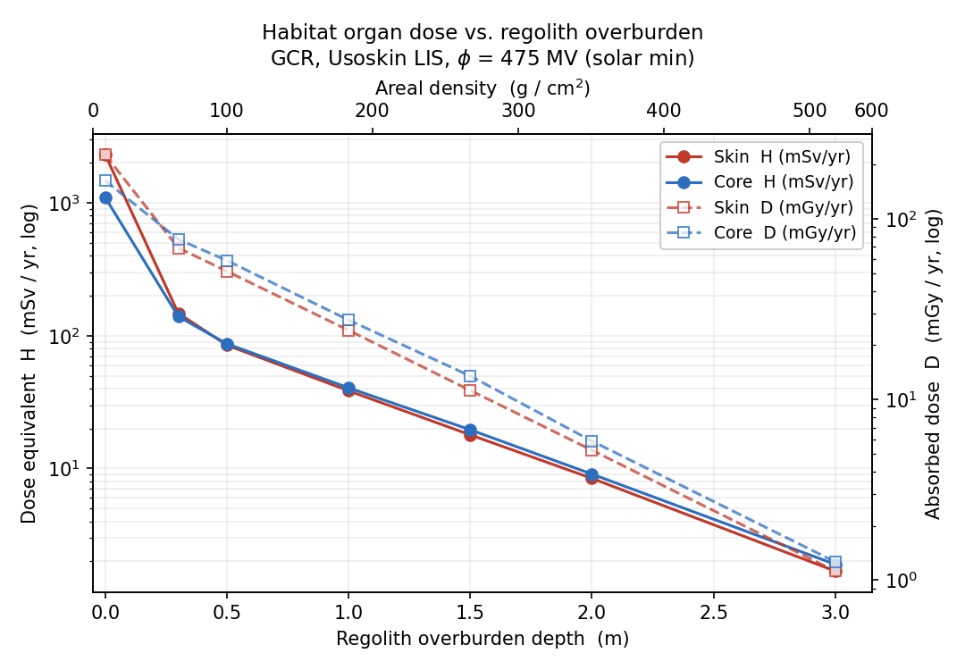
Figure 2. Dose equivalent vs regolith overburden.
Dose-equivalent falls steeply with depth:
Table 2. Dose equivalent with increasing regolith depth.
Depth (m) | Areal (g cm⁻²) | Skin H (mSv yr⁻¹) | Core H (mSv yr⁻¹)
0.0 | 0 | 2297 | 1096
0.3 | 56 | 148 | 140
0.5 | 98 | 85 | 87
1.0 | 187 | 39 | 41
1.5 | 276 | 18 | 20
2.0 | 365 | 8.4 | 9.1
3.0 | 543 | 1.7 | 1.9
The first ≈0.3 m of regolith removes the large bare-surface skin excess (2297 to 148 mSv yr⁻¹), after which skin and core converge and decline roughly an order of magnitude per ≈0.5–0.7 m. Beyond ≈1 m the annual dose-equivalent is already a small fraction of the NASA 600 mSv and ESA 1000 mSv career benchmarks [6,7], which bound a multi-year surface stay.

3.4 Representative shielded habitat (SSDW design case)
A representative well-shielded design evaluated at the 2026 Space Station Design Workshop (a habitat behind 2.5 m of regolith (445 g cm⁻²)) yields a crew-phantom core GCR dose-equivalent of 37.4 mSv yr⁻¹ at the self-shielded central crew phantom and 42.9 mSv yr⁻¹ averaged over the whole-envelope skin lining, both under the ICRP-60 quality factor, shown in Figure 3 below.
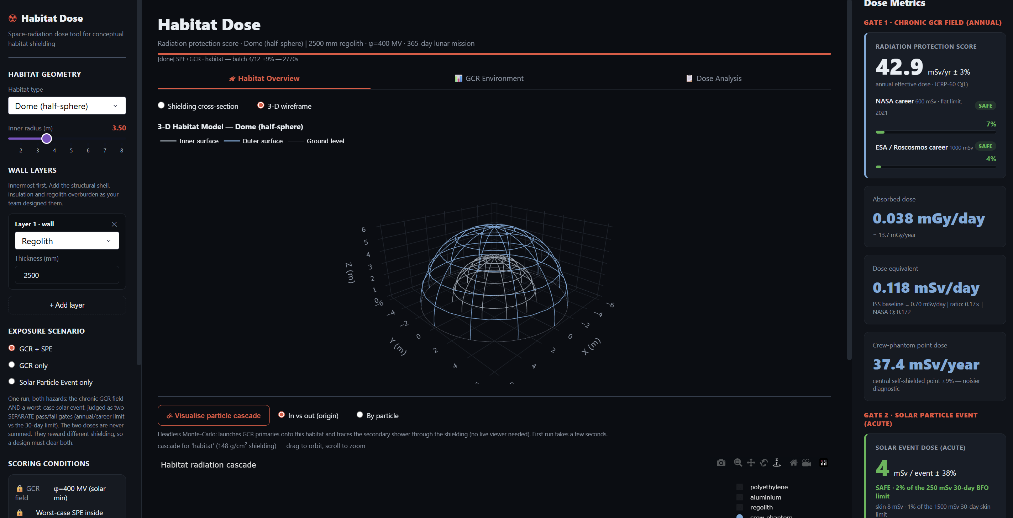
Figure 3. Regolith shielded dome.

3.5 Quality-factor model dependence and the thin-wall over-read
Reporting the identical transported field under both quality-factor models isolates the model dependence of the dose-equivalent: the crew-habitat skin-lining dose-equivalent rises from 42.9 mSv yr⁻¹ (mean Q̄ = 3.13) under the ICRP-60 Q(L) convention to 62.8 mSv yr⁻¹ (Q̄ = 4.58) under the NASA/Cucinotta-2013 formulation which represents a factor of 1.46, consistent with the documented HZETRN–Geant4 spread in heavy-ion quality weighting.
Below the ≈19 g cm⁻² kernel/flood crossover the mean quality factor over-reads the deterministic reference: the thin-wall Q̄ spans ≈5.3–5.6, i.e. ≈2.3–2.4× the OLTARIS value (≈2.3) at 10 g cm⁻². This over-read is robust to the nuclear-fragmentation model. Swapping the Geant4 ion-inelastic model from FTFP_BERT_HP default to QMD (16 seed replicas, otherwise-identical modular lists) raises the folded Q̄ by ≈7 % (5.29 to 5.64) rather than lowering it, confirming it as a genuine cross-code difference rather than a physics-list artifact. At depth the mean quality factor agrees with the reference: at 50 g cm⁻² the kernel Q̄ (≈2.2) matches the OLTARIS value, so the over-read is confined to the thin-wall kernel regime and does not propagate to the shielded design doses, which are evaluated above the crossover by the flood estimator.

3.6 Secondary-neutron dose fraction
The lineage-filtered scorer (§2.5) reports the wall- and regolith-bred albedo-neutron contribution directly and normalisation-independently.
In the 2.5 m regolith design case, the secondary-neutron cascade bred in the regolith overburden dominates the residual field: lineage-tracing the dose back to its initiating particle attributes the majority of the crew skin-lining GCR dose-equivalent to albedo neutrons (twin scorer summed over the full H–He–C–Si–Fe composition). This full-composition value supersedes an earlier proton-only estimate of ≈ 69 %, which under-counted the neutron share because it omitted the copious spallation neutrons produced by the heavy-ion component. At this depth the primary ions are largely stopped or fragmented, leaving a high-quality-factor neutron field that carries most of the equivalent dose.

4. Conclusions
A Monte Carlo radiation-simulation tool for the conceptual design of lunar surface habitats has been developed on the TOPAS/Geant4 platform. The tool constructs the galactic-cosmic-ray and solar-particle-event environments from first principles via a force-field-modulated local interstellar spectrum sampled over a directionally exact upper-hemisphere sky-dome. It transports them through user-defined habitat geometries and layered shielding, and reports absorbed dose, dose-equivalent under both the ICRP-60 and NASA/Cucinotta quality-factor models, and a lineage-resolved secondary-neutron fraction, with the GCR and SPE contributions kept strictly separate.
The absolute scale is fixed by a single scalar normalisation anchored once to the Chang’E-4 LND surface absorbed dose; every other comparison is therefore an independent test rather than a fitted agreement. Against the OLTARIS deterministic code, the tool reproduces the directly comparable channels to a few per cent: absorbed dose to ≈5 % at 54 g cm⁻² aluminium, and skin dose-equivalent to the SHARC/OLTARIS surface value at matched shielding. The whole-body effective dose is reported as the tool’s independent, target-blind estimate (≈135–200 mSv yr⁻¹ across the ICRP-60 and NASA quality-factor models at ≈150 g cm⁻²), with the heavy-ion quality-factor model identified as the dominant source of its spread; it is not matched to a deterministic effective dose, as no like-for-like reference at the same depth was available. This spread is consistent with the documented difference between Geant4 and HZETRN heavy-ion quality weighting rather than with a transport error, as confirmed by the fragmentation-model sensitivity test.
Deep-shield organ dose is recovered by a pre-computed response kernel whose regime of validity, and the crossover to direct flood transport, are stated explicitly; the kernel’s documented deep bias and thin-wall quality-factor over-read are reported as characterized limitations rather than corrected away. In the representative 2.5 m regolith design case the residual crew field is dominated by regolith- and wall-bred albedo neutrons, underlining the need for high-precision neutron transport in any surface-habitat shielding assessment.
The tool is intended for early-stage trade studies: it makes the assumptions and limits of each simulation explicit and lets designers compare candidate geometries and layered shielding on a common, physically grounded basis. Its principal limitations are the five-species heavy-ion lumping, the per-nucleon energy ceiling, and the quality-factor-model dependence of the effective dose. These are stated with each result, and bound the confidence of the predicted exposures accordingly.
References
[1] Dobynde MI, Guo J. Radiation environment at the surface and subsurface of the Moon: model development and validation. J. Geophys. Res. Planets 126 (2021) e2021JE006930.
[2] Blunier S, Athanasopoulos D, Dittmar C, Thoresen F, Cowley A, Fogtman A. Regolith-based lunar habitat for astronaut radiation protection and organ dose assessment. Planet. Space Sci. 261 (2025) 106116.
[3] Usoskin IG, Alanko-Huotari K, Kovaltsov GA, Mursula K. Heliospheric modulation of cosmic rays: monthly reconstruction for 1951–2004. J. Geophys. Res. 110 (2005) A12108.
[4] Zhu BX, Whitman K, Jun I, Ratliff JM. Comparison of JPL and ESP solar proton fluence models using the background-subtracted RDSv2.0 data set. Space Weather 21 (2023) e2022SW003311.
[5] NCRP. Radiation protection guidance for activities in low-Earth orbit. NCRP Report No. 132 (2000).
[6] NASA. Space Flight Human-System Standard, Volume 1: Crew Health. NASA-STD-3001 Vol. 1, Rev. C (2023).
[7] Durante M, Cucinotta FA. Physical basis of radiation protection in space travel. Rev. Mod. Phys. 83 (2011) 1245–1281.
[8] Reitz G, et al. Astronaut's organ doses inferred from measurements in a human phantom outside the International Space Station. Radiat. Res. 171 (2009) 225–235.
[9] Connolly J, Carrier WD. An engineering guide to lunar geotechnical properties. Proc. IEEE Aerospace Conf. (2023) 10.1109/AERO55745.2023.10115961.
[10] Akisheva Y, Gourinat Y. Utilisation of Moon regolith for radiation protection and thermal insulation in permanent lunar habitats. Appl. Sci. 11 (2021) 3853.
[11] Kunja LA, Kim E, Yi Y, Sohn J, Jung J. Capability of lunar regolith with hydrogenous materials as shielding material against GCR and SPE on the surface of Moon studied using OLTARIS. Adv. Space Res. 76 (2025) 2951–2959.
[12] Cucinotta FA, Kim MYH, Ren L. Evaluating shielding effectiveness for reducing space radiation cancer risks. Radiat. Meas. 41 (2006) 1173–1185.
[13] Burahmah NT, Heilbronn LH. Comparison of doses in lunar habitats located at the surface and in a crater. Aerospace 10 (2023) 970.
[14] Agostinelli S, et al. Geant4-a simulation toolkit. Nucl. Instrum. Methods Phys. Res. A 506 (2003) 250–303.
[15] Allison J, et al. Recent developments in Geant4. Nucl. Instrum. Methods Phys. Res. A 835 (2016) 186–225.
[16] Perl J, Shin J, Schümann J, Faddegon B, Paganetti H. TOPAS: an innovative proton Monte Carlo platform for research and clinical applications. Med. Phys. 39 (2012) 6818–6837.
[17] Singleterry RC Jr, Blattnig SR, Clowdsley MS, Qualls GD, Sandridge CA, Simonsen LC, et al. OLTARIS: On-Line Tool for the Assessment of Radiation in Space. NASA/TP-2010-216722 (2010).
[18] Slaba TC, Blattnig SR, Badavi FF. Faster and more accurate transport procedures for HZETRN. J. Comput. Phys. 229 (2010) 9397–9417.
[19] Gleeson LJ, Axford WI. Solar modulation of galactic cosmic rays. Astrophys. J. 154 (1968) 1011–1026.
[20] Cucinotta FA, Kim MHY, Chappell LJ. Space radiation cancer risk projections and uncertainties – 2012. NASA/TP-2013-217375 (2013).
[21] Simpson JA. Elemental and isotopic composition of the galactic cosmic rays. Annu. Rev. Nucl. Part. Sci. 33 (1983) 323–381.
[22] George JS, et al. Elemental composition and energy spectra of galactic cosmic rays during solar cycle 23. Astrophys. J. 698 (2009) 1666–1681.
[23] King JH. Solar proton fluences for 1977–1983 space missions. J. Spacecr. Rockets 11 (1974) 401–408.
[24] ICRP. 1990 Recommendations of the International Commission on Radiological Protection. ICRP Publication 60, Ann. ICRP 21 (1–3) (1991).
[25] Zhang S, et al. First measurements of the radiation dose on the lunar surface. Sci. Adv. 6 (2020) eaaz1334.
[26] Geant4 Collaboration. G4NDL 4.6 high-precision neutron data library (bundled with Geant4 10.7.p03). See Geant4 Data File Citation Guidelines and Mendoza E, Cano-Ott D, Capote R. Update of the Evaluated Neutron Cross Section Libraries for the Geant4 Code. IAEA INDC(NDS)-0758 (2018). https://geant4.web.cern.ch/download/data_files_citations.
[27] Heiken GH, Vaniman DT, French BM (eds.). Lunar Sourcebook: A User's Guide to the Moon. Cambridge University Press, Cambridge (1991).
[28] Workman RL, et al. (Particle Data Group). Review of particle physics. Prog. Theor. Exp. Phys. 2022 (2022) 083C01.
[29] Wilson JW, et al. Transport methods and interactions for space radiations. NASA RP-1257 (1991).

